iOS mOcean SDK

Developer Guide

For iOS Version 2.7.0

Table of Contents

System Requirements 5

Feature list 6

Installing the Ad SDK 7

Add the Latest version of SDK library project to your app 7

Add Frameworks and libraries to your project 8

Set Target Dependencies 9

Install Documentation 10

Simple AdView integration 11

Simple AdInterstitialView integration 12

Customize AdView 13

Customize view appearance. 13

Customize content. 13

Customize AdInterstitialView 14

Customize view appearance. 14

Customize content. 14

Troubleshooting 15

Duplicate symbol compile error 15

Remove 3rd party library from SDK 16

AdView Class Reference 17

Overview 17

Tasks 17

Initializing an AdView Object 17

Configuring the AdView 17

Loading the AdView Content 18

Filtering the AdView Content 18

Install Notification 18

Debug the AdView 18

Setting the Delegate 18

Properties 19

adServerUrl 19

additionalParameters 19

advertiserId 19

animateMode 20

area 20

carrier 20

city 20

contentAlignment 21

contentSize 21

country 21

defaultImage 22

delegate 22

groupCode 22

internalOpenMode 23

isLoading 23

keywords 23

latitude 24

logMode 24

longitude 24

maxSize 25

metro 25

minSize 25

premium 26

region 26

site 26

testMode 27

textColor 27

type 27

updateTimeInterval 28

zip 28

zone 28

Instance Methods 29

initWithFrame:site:zone: 29

update 29

AdInterstitialView Class Reference 31

Overview 31

Tasks 31

Customizing AdInterstitialView Closing 31

Setting the Delegate 31

Properties 31

autocloseInterstitialTime 31

closeButton 32

delegate 32

showCloseButtonTime 32

AdViewDelegate Protocol Reference 33

Overview 33

Tasks 33

Instance Methods 33

adDidEndFullScreen: 33

adShouldOpen:withUrl: 34

adWillStartFullScreen: 34

didFailToReceiveAd:withError: 35

didReceiveAd: 35

ormmaProcess:event:parameters: 35

willReceiveAd: 36

AdInterstitialViewDelegate Protocol Reference 37

Overview 37

Tasks 37

Instance Methods 37

didClosedInterstitialAd:usageTimeInterval: 37

# System Requirements

* Intel based Mac
* iOS 4.0 - 5.0 SDK
* XCode 4

# Feature list

* **HTML / JS ads**

SDK support displaying web ads using UIWebView component.

* **Video ads**

SDK support playing video ads in clickable MPMoviePlayerController component.

* **Location auto detect**

SDK could automatically detecting user location

* **User-Agent auto detect**

SDK automatically detects device User-Agent

* **Ad visibility tracking**

SDK automatically detects ads visibility for controlling updates and video playback

* **Logging**

SDK support logging.

* **Content caching**

All content cached

* **Internal browser**

SDK contains built-in browser for displaying ads in application

* **Millennial 3rd party**

SDK includes Millennial library. [See more.](http://www.millennialmedia.com/)

* **Google AdMob 3rd party**

SDK includes AdMob library. [See more.](http://www.admob.com/)

* **Rhythm 3rd party**

SDK includes Rhythm library. [See more.](http://www.rhythmnewmedia.com/)

* **Greystripe 3rd party**

SDK includes Greystripe library. [See more.](http://www.greystripe.com/)

* **iAd 3rd party**

SDK support iAd framework. [See more.](http://advertising.apple.com/)

* **iVdopia 3rd party**

SDK includes iVdopia library. [See more.](http://mobile.vdopia.com/)

* **SmartAdServer 3rd party**

SDK includes SmartAdServer library. [See more.](http://www.smartadserver.us/)

* **ORMMA level 1,2,3**

SDK support all ORMMA levels. [See more](http://code.google.com/p/ormma/).

# Installing the Ad SDK

## Add the Latest version of SDK library project to your app

Add the AdView.h, AdInterstitialView.h, AdDelegate.h header files from Public folder in SDK sources and library project.

Select Classes, then right-click and select Add Files to “Project Name”...

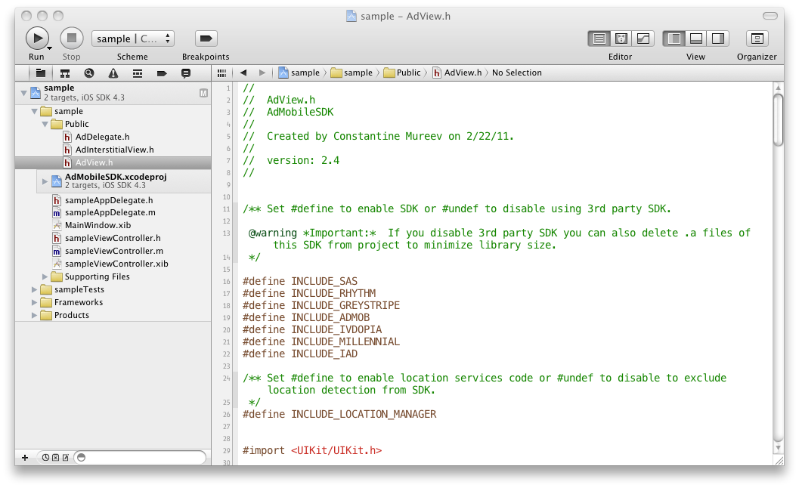

## Add Frameworks and libraries to your project

Add following frameworks and libraries to you project:

* **libAdMobileSDK.a**
* AudioToolbox
* AVFoundation
* CFNetwork
* CoreGraphics
* CoreMotion
* CoreTelphony
* iAd
* libsqlite3.0
* libz.1
* MediaPlayer
* MessageUI
* QuartzCore
* SystemConfiguration

Select Project, Target, Build Phases, then add frameworks in “Link Binary With Libraries” section

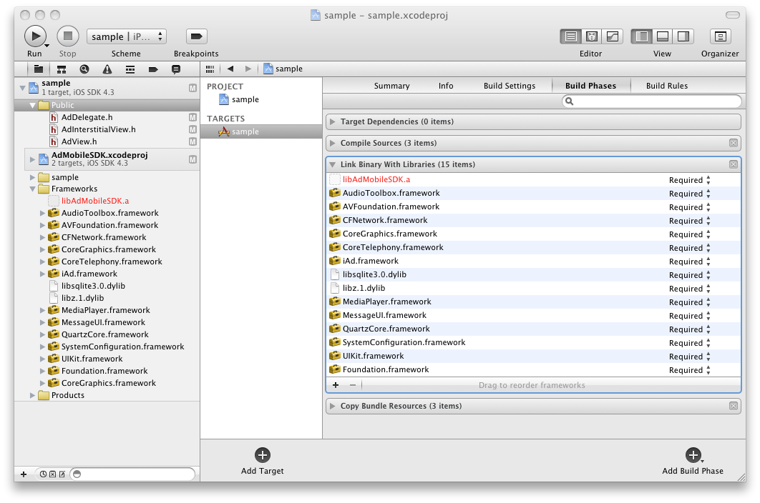

## Set Target Dependencies

Select Project, Target, Build Phases, then add AdMobileSDK target in “Target Dependencies” section.

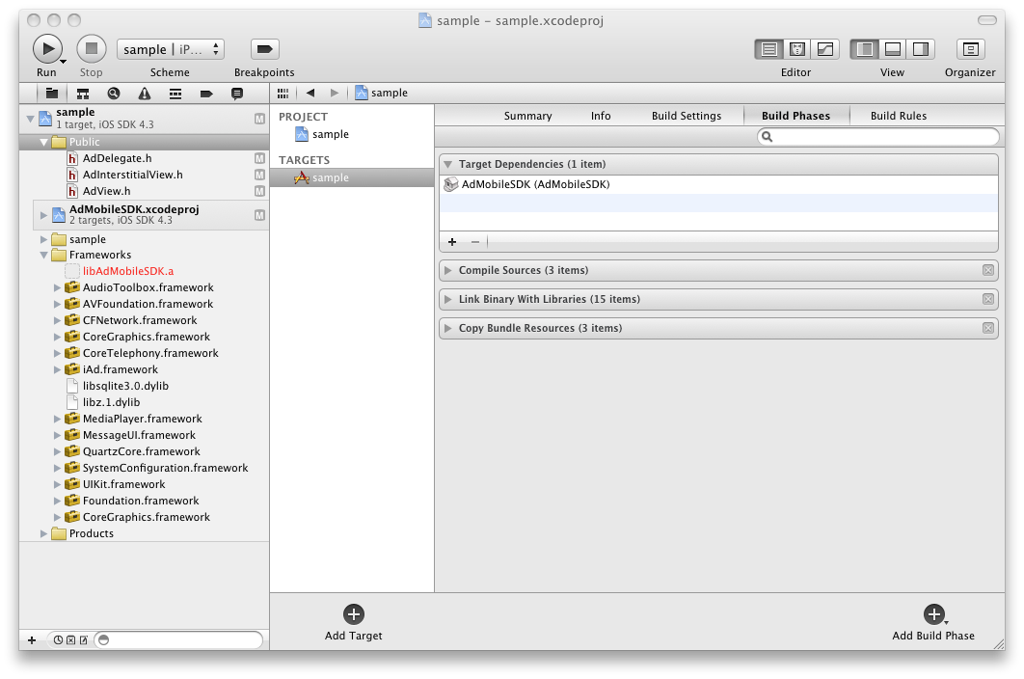

## Install Documentation

SDK includes XCode documentation in “Documentation\Reference” folder.

Run installdocset.sh script in Terminal.app to copy documentation to XCode or you can use web based version of documentation in html folder

# Simple AdView integration

To add AdView into your application just import AdView.h

#import "AdView.h"

And put initialize code in (void)viewDidLoad method

- (void)viewDidLoad {

AdView *adView = [[AdView alloc] initWithFrame:CGRectMake(0, 0, 320, 50) site:8061 zone:20249];

[self.view addSubview:adView];

[adView release];

[super viewDidLoad];

}

See Also:

* For more code samples see AdMobileSamples application.

# Simple AdInterstitialView integration

To add AdInterstitialView into your application just import AdInterstitialView.h

#import "AdInterstitialView.h"

And put initialize code in (void)viewDidLoad method

- (void)viewDidLoad {

AdInterstitialView *adView = [[AdInterstitialView alloc] initWithFrame:CGRectMake(0, 20, 320, 460) site:8061 zone:16112];

adView.minSize = CGSizeMake(320, 460);

[self.navigationController.view addSubview:adView];

[adView release];

[super viewDidLoad];

}

For more customization you can set custom close button, delay for showing button or auto close interstitial time.

See Also:

* For more code samples see AdMobileSamples application.

# Customize AdView

## Customize view appearance.

1. By default in AdView enabled animation and internalOpenMode.

To disable default animation set animateMode property to NO. **Important**: you need to disable animation if you specify your own.

2. Also you can set defaultImage property to show image while ad loading.

3. Set contentAlignment property to enable auto alignment content in center vertically and horizontally.

4. Also you can apply default UIView customization such as animation, background color, support different orientations and so on.

## Customize content.

1. By default in SDK disabled location auto detect. If you want to filter content by user location set latitude and longitude property of AdView.

Also you could enable auto detect location by replacing “#undef INCLUDE_LOCATION_MANAGER” with «#define INCLUDE_LOCATION_MANAGER” in AdView.h and adding CoreLocation framework.

**Important:** However do not use Core Location just for advertising, make sure it is used for more beneficial reasons as well. It is both a good idea and part of Apple's guidelines.

2. For Rhythm SDK support CoreLocation framework is required. So by default it is disabled: ”#undef INCLUDE_RHYTHM” in AdView.h file. To enable Rhythm SDK support add CoreLocation framework to your project, add libRhythmSDK.a to AdMobileSDK project and replace ”#undef INCLUDE_RHYTHM” with ”#define INCLUDE_RHYTHM” in AdView.h.

3. To add additionally filtration you can set keywords, city, carrier, metro, etc.

# Customize AdInterstitialView

## Customize view appearance.

1. By default for interstitial created rounded white close button. You can customize button by setting your own.

2. To enable auto close interstitial timer set time interval autoCloseInterstitial property, in seconds.

3. You can delay close button displaying by setting showCloseButtonTime property.

## Customize content.

See customize section of AdView

# Troubleshooting

## Duplicate symbol compile error

If you got compile error like this:

/Users/william/Library/Developer/Xcode/DerivedData/theScoreMobile-testApp/Build/Products/Debug-iphoneos/libAdMobileSDK.a(SBJSON.o)"

It means that your project and SDK contains files with same name. In most cases this error due to duplication some framework. In this case – SBJSON.

To solve this problem you need to remove .m files for all files than cause this error. In this case – keep SBJSON.h and remove SBJSON.m and so on…

# Remove 3rd party library from SDK

To remove any 3rd party SDK follow steps below. Here example how to remove Google AdMob SDK.

1. Replace ”#define INCLUDE_ADMOB” with ”#undef INCLUDE_ADMOB” in AdView.h file

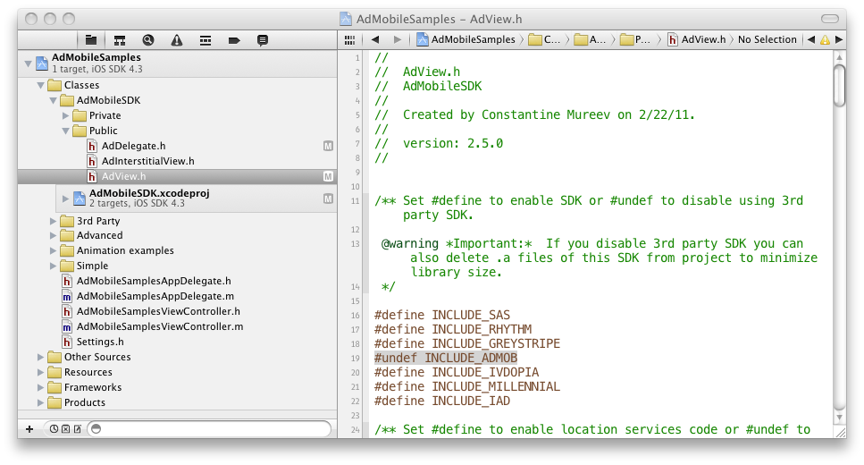

2. Remove .a files from Google AdMob SDK in AdMobileSDK project. You can keep files and remove reference only. It's also minimize application binary size.

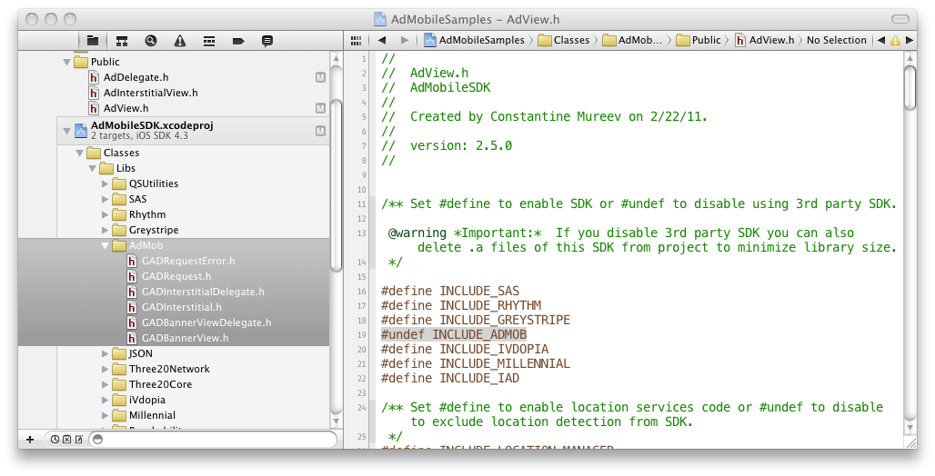

# AdView Class Reference

|  |  |
| --- | --- |
| **Inherits from** | UIView |
| **Declared in** | AdView.h |

## Overview

You use the AdView class to embed advertisement content in your application. To do so, you simply create an AdView object and add it to a UIView. An instance of AdView (or simply, an ad) is a means for displaying advertisement information from ad publisher site. To choose ad publisher site set parameters in the ad initialization method initWithFrame:site:zone: or use the properties site and zone. Use the adServerUrlproperty to choose ad publisher server.

Ad handles the rendering of any content in its area: HTML, Video, Gif animation or JavaScript. Ad also handles any interactions with that content. So you can link from the banner to ad publisher site. Use theinternalOpenMode property to set open mode for ad publisher site. To control all intercations implementAdViewDelegate protocol.

Ad always tries to load the content after creation. The time interval between load requests is managed using the property updateTimeInterval. Also you can update ad content immediately using the update method. Use the isLoading property to find out if ad is in the process of loading.

To configure ad visual appearance use the properties defaultImage, textColor or contentAlignment. To manage the ad animation use the property animateMode.

Advanced ad customization is supported. So you can filter the ad content using the premium property. Use the properties minSize and maxSize to configure ad content size in server response. Also you can set the search parameters or any other parameters using the properties keywords and additionalParametersaccordingly.

To debug ad behavior use the properties testMode and logMode.

Set the delegate property to an object conforming to the AdViewDelegate protocol if you want to track the processing of ad content.

## Tasks

### Initializing an AdView Object

* – initWithFrame:site:zone:

### Configuring the AdView

* site *property*
* zone *property*
* adServerUrl *property*
* defaultImage *property*
* animateMode *property*
* contentAlignment *property*
* internalOpenMode *property*
* textColor *property*

### Loading the AdView Content

* isLoading *property*
* updateTimeInterval *property*
* – update
* contentSize *property*

### Filtering the AdView Content

* premium *property*
* adsType *property*
* type *property*
* keywords *property*
* minSize *property*
* maxSize *property*
* additionalParameters *property*
* latitude *property*
* longitude *property*
* country *property*
* region *property*
* city *property*
* area *property*
* metro *property*
* zip *property*
* carrier *property*

### Install Notification

* advertiserId *property*
* groupCode *property*

### Debug the AdView

* testMode *property*
* logMode *property*

### Setting the Delegate

* delegate *property*

## Properties

### adServerUrl

Publisher server url.

@property (retain) NSString *adServerUrl

#### Discussion

Publisher server url.

The default value is http://ads.AdMobile.mobi/ad .

#### Declared In

AdView.h

### additionalParameters

Custom request parameters.

@property (retain) NSDictionary *additionalParameters

#### Discussion

Custom request parameters.

Use this property to add custom request parameters.

The default value is nil.

**Note:** All keys and objects is need to be kind of NSString Class. For example:

[NSDictionary dictionaryWithObject:@"value" forKey:@"key"]

#### Declared In

AdView.h

### advertiserId

Id of the advertiser for install notification.

@property (assign) NSInteger advertiserId

#### Discussion

Id of the advertiser for install notification.

**Note:** Install notification enabled only if advertiserId and groupCode are specified.

#### Declared In

AdView.h

### animateMode

A Boolean value that determines whether ad animate mode is enabled.

@property BOOL animateMode

#### Discussion

A Boolean value that determines whether ad animate mode is enabled.

Setting the value of this property to YES enables ad animate mode and setting it to NO disables this mode.

The default value is YES.

#### Declared In

AdView.h

### area

Area code of a user. For US only.

@property (retain) NSString *area

#### Discussion

Area code of a user. For US only.

The default value is nil.

#### Declared In

AdView.h

### carrier

User carrier.

@property (retain) NSString *carrier

#### Discussion

User carrier.

The default value is nil.

#### Declared In

AdView.h

### city

City of the device user (with state). For US only.

@property (retain) NSString *city

#### Discussion

City of the device user (with state). For US only.

The default value is nil.

#### Declared In

AdView.h

### contentAlignment

A Boolean value that determines whether content alingment center vertically and horizontally.

@property BOOL contentAlignment

#### Discussion

A Boolean value that determines whether content alingment center vertically and horizontally.

Setting the value of this property to YES enables auto warapping server reponse content in HTML table with aligment

The default value is NO.

**Important:** You need to disable animation if you specify your own.

#### Declared In

AdView.h

### contentSize

Size of the ad content to be shown.

@property (readonly) CGSize contentSize

#### Discussion

Size of the ad content to be shown.

Use this property to get the actual size of the ad content. Property value updated after ad content downloaded.

**Note:** If size unavailable (Millennial, Greystripe, iVdopia and other 3rd party SDKs) property returns CGRectZero.

#### Declared In

AdView.h

### country

Country of visitor. It overrides country detected by IP. It is ISO 3166 to be used for specifying country code.

@property (retain) NSString *country

#### Discussion

Country of visitor. It overrides country detected by IP. It is ISO 3166 to be used for specifying country code.

The default value is nil.

#### Declared In

AdView.h

### defaultImage

Image for unloaded ad state.

@property (retain) UIImage *defaultImage

#### Discussion

Image for unloaded ad state.

Settings the value of this property determines ad default image for unloaded state. In this state the content of ad is invisible and ad default image is displayed. Without connection to the internet default image also will be displayed.

The default value is nil.

#### Declared In

AdView.h

### delegate

The receiver’s delegate.

@property (assign) id<AdViewDelegate> delegate

#### Discussion

The receiver’s delegate.

The AdView is sent messages when content is processing. The delegate must adopt the AdViewDelegateprotocol. The delegate is not retained.

**Important:** Before releasing an instance of AdView for which you have set a delegate, you must first set its delegate property to nil. This can be done, for example, in your dealloc method.

#### See Also

* AdViewDelegate Protocol Reference for the optional methods this @property delegate may implement.

#### Declared In

AdView.h

### groupCode

Group code for install notification.

@property (retain) NSString *groupCode

#### Discussion

Group code for install notification.

**Note:** Install notification enabled only if advertiserId and groupCode are specified.

#### Declared In

AdView.h

### internalOpenMode

A Boolean value that determines whether ad internal browser is enabled.

@property BOOL internalOpenMode

#### Discussion

A Boolean value that determines whether ad internal browser is enabled.

Setting the value of this property to NO disables internal browser, so after linking from the banner the ad publisher site will be opened in Safari.

To handle opening/closing internal browser use AdView delegate or viewWillAppear/viewWillDisappear methods of UIViewController.

The default value is YES.

#### Declared In

AdView.h

### isLoading

A Boolean value that determines whether ad is in the process of loading.

@property (readonly) BOOL isLoading

#### Discussion

A Boolean value that determines whether ad is in the process of loading.

#### Declared In

AdView.h

### keywords

Keywords for search ads.

@property (retain) NSString *keywords

#### Discussion

Keywords for search ads.

Use this property to search ads. The values are delimited by commas.

The default value is nil.

#### Declared In

AdView.h

### latitude

User location latitude value.

@property (retain) NSString *latitude

#### Discussion

User location latitude value.

Use this property to set latitude. The value @“” will stop coordinates auto-detection and coordinates will not be sent to server. Any other values also will stop coordinates auto-detection but coordinates will be sent to server.

The default value is auto-detected by locationManager and sent to server.

#### Declared In

AdView.h

### logMode

AdLogMode value that determines log level.

@property AdLogMode logMode

#### Discussion

AdLogMode value that determines log level.

typedef enum {

AdLogModeNone = 0,

AdLogModeErrorsOnly = 1,

AdLogModeAll = 2,

} AdLogMode;

Setting the value of this property to AdLogModeNone disables ads logging. AdLogModeErrorsOnly – enables logging errors only. AdLogModeAll – enables logging errors and infos.

The default value is AdLogModeErrorsOnly.

#### Declared In

AdView.h

### longitude

User location longitude value.

@property (retain) NSString *longitude

#### Discussion

User location longitude value.

Use this property to set longitude. The value @“” will stop coordinates auto-detection and coordinates will not be sent to server. Any other values also will stop coordinates auto-detection but coordinates will be sent to server.

The default value is auto-detected by locationManager and sent to server.

#### Declared In

AdView.h

### maxSize

Maximal size of the ad content to be shown.

@property CGSize maxSize

#### Discussion

Maximal size of the ad content to be shown.

Use this property to set the maximal size of the ad content and server response will be close to this size.

#### Declared In

AdView.h

### metro

Metro code of a user. For US only.

@property (retain) NSString *metro

#### Discussion

Metro code of a user. For US only.

The default value is nil.

#### Declared In

AdView.h

### minSize

Minimal size of the ad content to be shown.

@property CGSize minSize

#### Discussion

Minimal size of the ad content to be shown.

Use this property to set the minimal size of the ad content and server response will be close to this size.

#### Declared In

AdView.h

### premium

Ad premium filter.

@property AdPremium premium

#### Discussion

Ad premium filter.

typedef enum {

AdPremiumNonPremium = 0,

AdPremiumPremium,

AdPremiumBoth,

} AdPremium;

Use this property to filter the content of ad by premium status.

The default value is AdPremiumNonPremium.

#### Declared In

AdView.h

### region

Region of visitor. ISO 3166-2 is used for United States and Canada and FIBS 10-4 is used for other countries.

@property (retain) NSString *region

#### Discussion

Region of visitor. ISO 3166-2 is used for United States and Canada and FIBS 10-4 is used for other countries.

The default value is nil.

#### Declared In

AdView.h

### site

Id of the publisher site.

@property (assign) NSInteger site

#### Discussion

Id of the publisher site.

Settings the value of this property determines the id of the publisher site, so switching between publisher sites is possible. The default value is copied from parameter site of ad initialization method.

#### Declared In

AdView.h

### testMode

A Boolean value that determines whether ads test mode is enabled. Setting the value of this property to YES enables ads test mode and setting it to NO disables ads test mode.

@property BOOL testMode

#### Discussion

A Boolean value that determines whether ads test mode is enabled. Setting the value of this property to YES enables ads test mode and setting it to NO disables ads test mode.

The default value is NO.

#### Declared In

AdView.h

### textColor

Color of ad text links.

@property (retain) UIColor *textColor

#### Discussion

Color of ad text links.

The default value is nil.

**Note:** Alpha value ignored.

#### Declared In

AdView.h

### type

Ad type filter.

@property AdType type

#### Discussion

Ad type filter.

typedef enum {

AdTypeTextOnly = 1,

AdTypeImagesOnly = 2,

AdTypeImagesAndText = 3,

AdTypeRichmedia = 4,

AdTypeRichmediaAndText = 5,

AdTypeRichmediaAndImages = 6,

AdTypeAll = 7,

} AdType;

Use this property to filter the content of ad by type.

The default value is AdTypeImagesAndText.

#### Declared In

AdView.h

### updateTimeInterval

Update time interval, in seconds.

@property NSTimeInterval updateTimeInterval

#### Discussion

Update time interval, in seconds.

The value of this property determines time interval between ads updating. This interval is counted after finish loading content, so the ad will start updating only after loading is finished and time interval is passed.

Setting value in range from 0 to 5 will apply 5 seconds to prevent too fast ad updates.

Setting to 0 will stop updates. All positive values enable updates.

The default value is 120.

#### Declared In

AdView.h

### zip

Zip/Postal code of user (note: parameter is all caps). For US only.

@property (retain) NSString *zip

#### Discussion

Zip/Postal code of user (note: parameter is all caps). For US only.

The default value is nil.

#### Declared In

AdView.h

### zone

Id of the publisher zone.

@property (assign) NSInteger zone

#### Discussion

Id of the publisher zone.

Settings the value of this property determines the id of the publisher zone, so switching between publisher zones is possible. The default value is copied from parameter zone of ad initialization method.

#### Declared In

AdView.h

## Instance Methods

### initWithFrame:site:zone:

Initializes and returns an AdView object having the given frame, site and zone.

- (id)initWithFrame:(CGRect)frame site:(NSInteger)site zone:(NSInteger)zone

#### Parameters

frame

A rectangle specifying the initial location and size of the ad view in its superview’s coordinates.

site

A value that specifies the id of ad publisher site.

zone

A value that specifies the id of ad publisher zone.

#### Return Value

Returns an initialized AdView object or nil if the object could not be successfully initialized.

#### Discussion

Initializes and returns an AdView object having the given frame, site and zone.

#### Declared In

AdView.h

### update

Starts to update the ad content immediately.

- (void)update

#### Discussion

Starts to update the ad content immediately.

Call this method if you want update the ad content immediately (for example, after setting site and zone or changing adServerUrl). If ad is in the process of loading it will be interrupted.

#### Declared In

AdView.h

# AdInterstitialView Class Reference

|  |  |
| --- | --- |
| **Inherits from** | AdView : UIView |
| **Declared in** | AdInterstitialView.h |

## Overview

The AdInterstitialView class is subclassing of AdView with advanced customization parameters. An instance of AdInterstitialView is a means for full-screen displaying ads with specific closing.

## Tasks

### Customizing AdInterstitialView Closing

* showCloseButtonTime *property*
* autocloseInterstitialTime *property*
* closeButton *property*

### Setting the Delegate

* delegate *property*

## Properties

### autocloseInterstitialTime

Auto close interstitial time interval, in seconds.

@property NSTimeInterval autocloseInterstitialTime

#### Discussion

Auto close interstitial time interval, in seconds.

Setting to 0 will disable auto closing interstitial.

The default value is 0.

#### Declared In

AdInterstitialView.h

### closeButton

Interstitial close button.

@property (retain) UIButton *closeButton

#### Discussion

Interstitial close button.

Set this value to customize close button appearance.

#### Declared In

AdInterstitialView.h

### delegate

The receiver’s delegate.

@property (assign) id<AdInterstitialViewDelegate> delegate

#### Discussion

The receiver’s delegate.

The AdInterstitialView is sent messages when content is processing. The delegate must adopt theAdInterstitialViewDelegate protocol. The delegate is not retained.

**Important:** Before releasing an instance of AdInterstitialView for which you have set a delegate, you must first set its delegate property to nil. This can be done, for example, in your dealloc method.

#### See Also

* AdInterstitialViewDelegate Protocol Reference for the optional methods this@property delegate may implement.

#### Declared In

AdInterstitialView.h

### showCloseButtonTime

Show close button delay time interval, in seconds.

@property NSTimeInterval showCloseButtonTime

#### Discussion

Show close button delay time interval, in seconds.

Setting to 0 will show close button immediately.

The default value is 0.

#### Declared In

AdInterstitialView.h

# AdViewDelegate Protocol Reference

|  |  |
| --- | --- |
| **Conforms to** | NSObject |
| **Declared in** | AdDelegate.h |

## Overview

The AdViewDelegate protocol defines methods that a delegate of a AdView object can optionally implement to receive notifications from ad.

## Tasks

* – willReceiveAd:
* – didReceiveAd:
* – didFailToReceiveAd:withError:
* – adWillStartFullScreen:
* – adDidEndFullScreen:
* – adShouldOpen:withUrl:

## Instance Methods

### adDidEndFullScreen:

Sent after an ad view finished displaying internal browser.

- (void)adDidEndFullScreen:(id)sender

#### Parameters

sender

The ad view has finished displaying internal browser.

#### Discussion

Sent after an ad view finished displaying internal browser.

#### Declared In

AdDelegate.h

### adShouldOpen:withUrl:

Sent before an ad view will start to open URL.

- (BOOL)adShouldOpen:(id)sender withUrl:(NSURL *)url

#### Parameters

sender

The ad view that is about to open URL.

url

The URL that should be opened in internal or external browser.

#### Return Value

Returns YES to allow SDK open browser otherwise returns NO.

#### Discussion

Sent before an ad view will start to open URL.

Implement this method with return NO value if you want to control opening ads by your self.

This method is optional. If you do not implement this method, the SDK accept YES as return value.

**Important:** This method may not calling on 3rd party SDKs (Millennial, Greystripe, iVdopia, …)

#### Declared In

AdDelegate.h

### adWillStartFullScreen:

Sent before an ad view will start to display internal browser.

- (void)adWillStartFullScreen:(id)sender

#### Parameters

sender

The ad view that is about to display internal browser.

#### Discussion

Sent before an ad view will start to display internal browser.

**Important:** This method called after adShouldOpen:withUrl: returns YES or not implemented.

**Important:** This method is not called on opening ads in Safari (internalOpenMode set to NO). To handle this behaviour implement UIApplicationDelegate protocol

#### Declared In

AdDelegate.h

### didFailToReceiveAd:withError:

Sent if an ad view failed to load ad content.

- (void)didFailToReceiveAd:(id)sender withError:(NSError *)error

#### Parameters

sender

The ad view that failed to load ad content.

error

The error that occurred during loading.

#### Discussion

Sent if an ad view failed to load ad content.

The same method can be invoked if the server does not currently advertising.

#### Declared In

AdDelegate.h

### didReceiveAd:

Sent after an ad view finished loading ad content.

- (void)didReceiveAd:(id)sender

#### Parameters

sender

The ad view has finished loading.

#### Discussion

Sent after an ad view finished loading ad content.

#### Declared In

AdDelegate.h

### ormmaProcess:event:parameters:

Sent after an ad process ORMMA command.

- (void)ormmaProcess:(id)sender event:(NSString *)event parameters:(NSDictionary *)parameters

#### Parameters

sender

The ad view that is about to open URL.

event

The string with name of the event.

parameters

The Dictionary with parameters from event.

#### Discussion

Sent after an ad process ORMMA command.

**Important:** Implement this method only if you want add additional logic for event. By default SDK alreadey emplements all methods and your code could conflict with SDK

#### Declared In

AdDelegate.h

### willReceiveAd:

Sent before an ad view will begin loading ad content.

- (void)willReceiveAd:(id)sender

#### Parameters

sender

The ad view that is about to load ad content.

#### Discussion

Sent before an ad view will begin loading ad content.

#### Declared In

AdDelegate.h

# AdInterstitialViewDelegate Protocol Reference

|  |  |
| --- | --- |
| **Conforms to** | AdViewDelegate |
| **Declared in** | AdDelegate.h |

## Overview

The AdInterstitialViewDelegate protocol defines methods that a delegate of a AdInterstitialView object can optionally implement to receive notifications from ad.

## Tasks

* – didClosedInterstitialAd:usageTimeInterval:

## Instance Methods

### didClosedInterstitialAd:usageTimeInterval:

Sent after an ad interstitial view closed and tracks the usage time of ad interstitial view.

- (void)didClosedInterstitialAd:(id)sender usageTimeInterval:(NSTimeInterval)usageTimeInterval

#### Parameters

sender

The ad interstitial view was closed.

usageTimeInterval

The usage time interval of ad interstitial view.

#### Discussion

Sent after an ad interstitial view closed and tracks the usage time of ad interstitial view.

#### Declared In

AdDelegate.h